Q.1 Given n non-negative integers representing the histogram’s bar height where the width of each bar is 1, find the area of largest rectangle in the histogram.

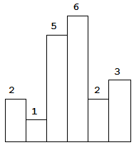

Above is a histogram where width of each bar is 1, given height = [2,1,5,6,2,3].

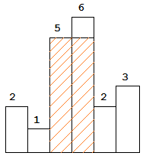 Ans: 10

Q.2. N number of books are given.   
The ith book has Pi number of pages.   
You have to allocate books to M number of students so that maximum number of pages alloted to a student is minimum. A book will be allocated to exactly one student. Each student has to be allocated atleast one book.

**NOTE:** Return -1 if a valid assignment is not possible, and allotment should be in contiguous order.

**Input:**  
 List of Books M number of students

Your function should return an integer corresponding to the minimum number.

**Example:** **P : [12, 34, 67, 90]**

**M : 2**

**Output : 113**

**There are 2 number of students. Books can be distributed in following fashion :**

**1) [12] and [34, 67, 90]**

**Max number of pages is allocated to student 2 with 34 + 67 + 90 = 191 pages**

**2) [12, 34] and [67, 90]**

**Max number of pages is allocated to student 2 with 67 + 90 = 157 pages**

**3) [12, 34, 67] and [90]**

**Max number of pages is allocated to student 1 with 12 + 34 + 67 = 113 pages**

**Of the 3 cases, Option 3 has the minimum pages = 113.**

Q.3. Implement a queue using stack(s).